27381

App Service in Cloud Computing

1. Introduction to Azure App Service
Azure App Service is a fully managed Platform-as-a-Service (PaaS) provided by Microsoft Azure. It is used to build, deploy, and scale web apps, mobile app backends, and RESTful APIs in a secure and scalable environment.
App Service supports multiple programming languages like:
- .NET
- Java
- PHP
- Python
- Node.js
- Ruby
Developers can deploy code from local machines, repositories like GitHub, or use containers. It integrates easily with DevOps tools and enables CI/CD pipelines.
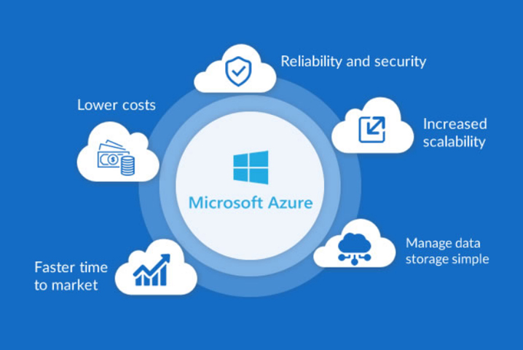

2. Key Features of App Service
- Managed Hosting: No need to manage the infrastructure manually.
- Auto-scaling: Automatically scale based on demand (manual, scheduled, or metric-based).
- Integrated Deployment: Support for GitHub, Azure DevOps, Bitbucket, and FTP.
- Custom Domains & SSL: Easily bind custom domains and secure them with free or custom SSL.
- Authentication & Authorization: Built-in integration with Azure AD, Google, Facebook, Twitter, and Microsoft Accounts.
- Staging Slots: Test new versions in staging before swapping to production.
- Global Availability: Host applications in data centers worldwide.
- Monitoring & Diagnostics: Integrated with Azure Monitor, Application Insights, and Log Analytics.

3. Azure App Service Architecture
Azure App Service abstracts all hardware and OS management so developers can focus on building apps. Here's how the architecture generally looks:
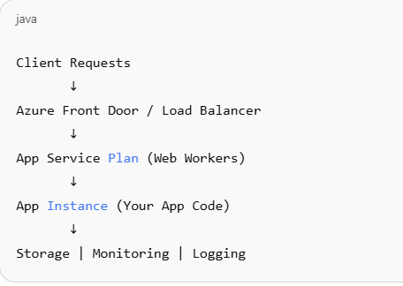
Components:
- Load Balancer: Routes traffic to app instances.
- App Service Plan: Defines compute resources (region, size, scaling).
- App Workers: VM-based infrastructure that runs your apps.
- Storage & Monitoring: Persistent storage for diagnostics, and telemetry via App Insights.
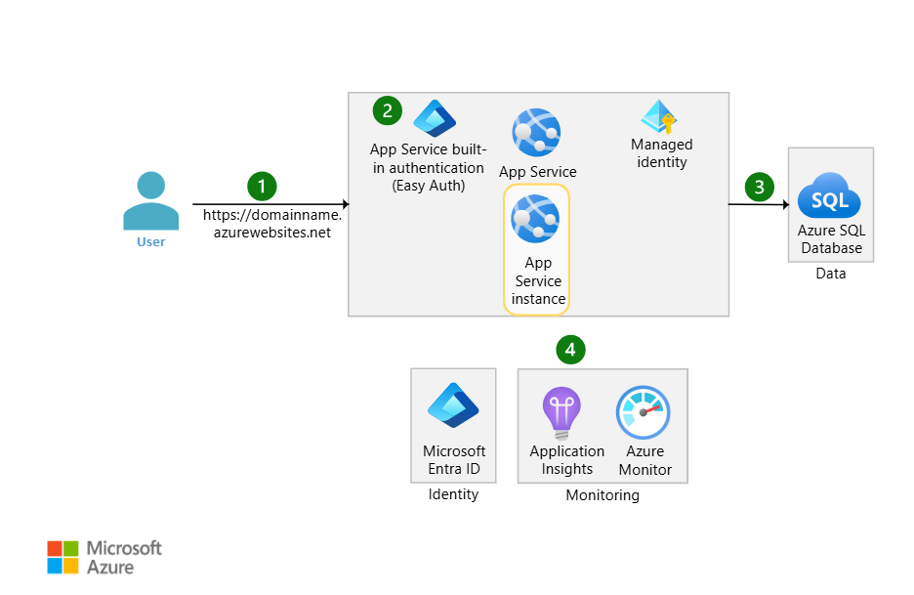

4. Deployment Options
Azure App Service supports many deployment methods:
- Local Git or GitHub
- GitHub Actions (CI/CD)
- Azure DevOps Pipelines
- FTP/SFTP
- Docker Containers
- Visual Studio/VS Code
- ARM Templates / Terraform (Infrastructure as Code)
This flexibility makes it ideal for both simple and complex deployment pipelines.

5. Use Cases
- Hosting business websites and e-commerce platforms
- Backend services for mobile applications
- Deploying REST APIs and microservices
- Lightweight serverless function replacements
- Prototyping and testing applications quickly

6. Pricing Tiers
Azure App Service offers different tiers based on compute power, features, and usage:
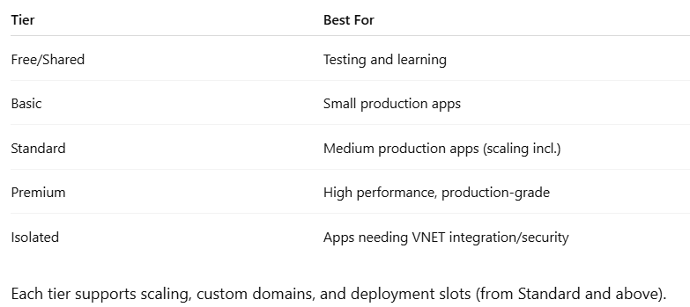

7. Benefits of Azure App Service
- Fast Deployment: Easily integrate with CI/CD.
- No Infrastructure Management: Fully managed PaaS.
- High Availability: SLA-backed uptime.
- Security: Built-in compliance and security features.
- Developer-Friendly: Native support for multiple frameworks.

8. Challenges
- Cost: Higher-tier plans can be expensive at scale.
- Limited Low-Level Access: Less control over server config.
- Cold Starts: Apps might take time to start after inactivity (in lower tiers).
- Vendor Lock-in: Heavily dependent on Microsoft ecosystem.

Conclusion
Azure App Service simplifies the process of hosting, scaling, and managing modern web apps. Whether you're an individual developer, a startup, or an enterprise, it provides the tools and infrastructure needed to deliver reliable and secure applications.

